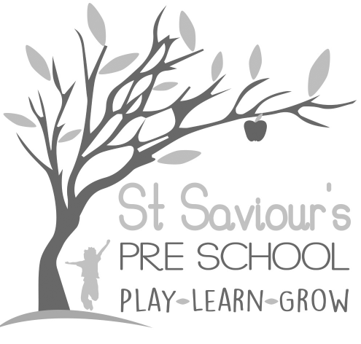

3.1 INDUCTION OF EMPLOYEES AND VOLUNTEERS

Written by: Claire Toms and Tina Alder Date: 1.09.22. – reviewed 28.8.25

Policy Statement
We provide an induction for all employees and volunteers to fully brief them about the setting, the families we serve, our policies and procedures, the EYFS 2025 curriculum requirements, and daily practice.

Procedures
Leaders provide induction training for all new staff, which includes the following:
- Introduction to all employees and volunteers.
- New practitioners are assigned a mentor from existing staff, for guidance in daily matters.
- Familiarisation with the building, and instruction on health, safety, safeguarding, and fire and evacuation procedures.
- Ensuring our policies and procedures are read, understood, adhered to, and signed.
- Introduction to the parents, especially parents of allocated key children where appropriate.
- Familiarisation with confidential information in relation to any key children.
- Details of the job description and daily timetable.
- During the induction period, the individual must demonstrate understanding of and compliance with policies, procedures, tasks, and routines.
- All new staff must complete safeguarding training (including child protection, Prevent Duty, and whistleblowing procedures) as part of their induction, in line with the EYFS 2025.
- New staff must also demonstrate awareness of inclusive practice, equality of opportunity, and supporting children with SEND as required by EYFS 2025.
- Successful completion of the induction forms part of the probationary period.
- Following induction, we continue to support our staff to deliver high quality performance through regular supervision and appraisal of their work.
- Records of induction, training completed, and probationary review outcomes will be documented and stored securely in staff files.

